**Noah**

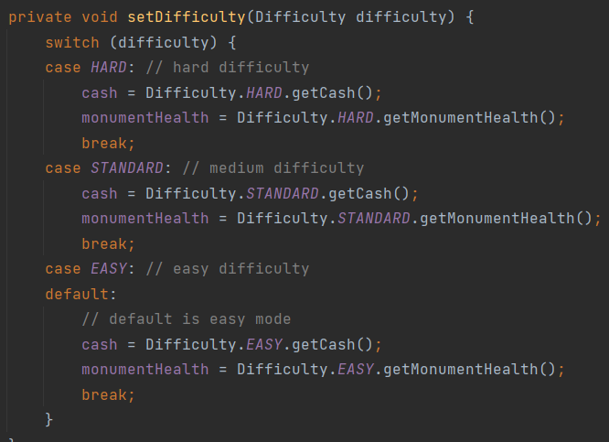In the GameScreen.java class, we use a switch statement to set the different variables associated with the difficulty type. This is an Object Oriented Abuser and needed to be fixed. In proper object oriented code, switch and if statements should be quite rare.

To fix this, the attributes for each difficulty type were included within the difficulty Enum class. This allows for shorter and cleared code to accomplish the same thing as the switch statement.

